Refer arithmetic.h

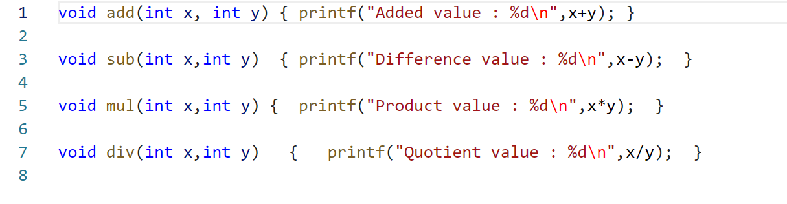

Refer including_arithmetic_header_file.c

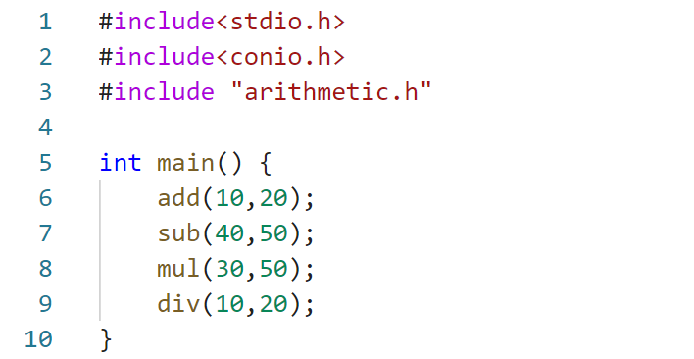

Output

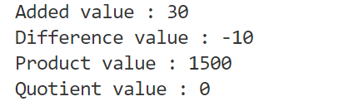

# Macros

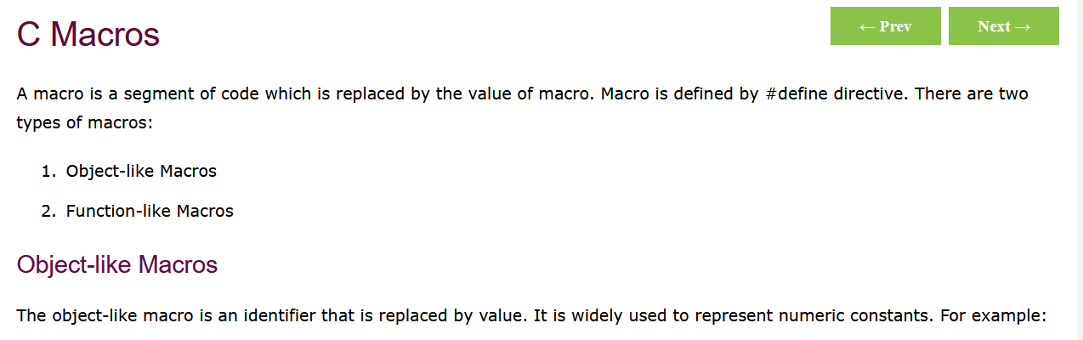

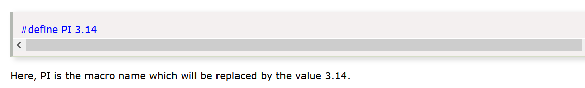

## Refer macros_1.c

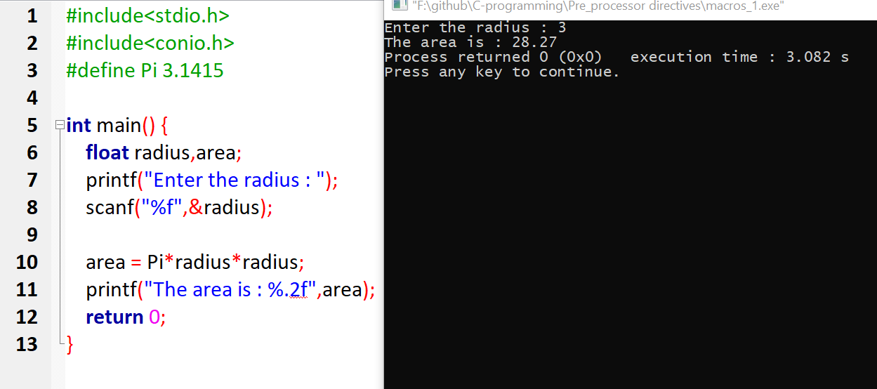

## Refer macros_2.c

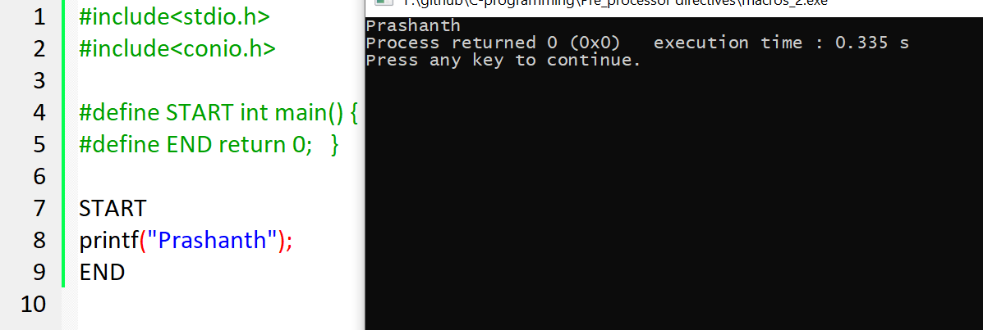

## Refer macros_3.c

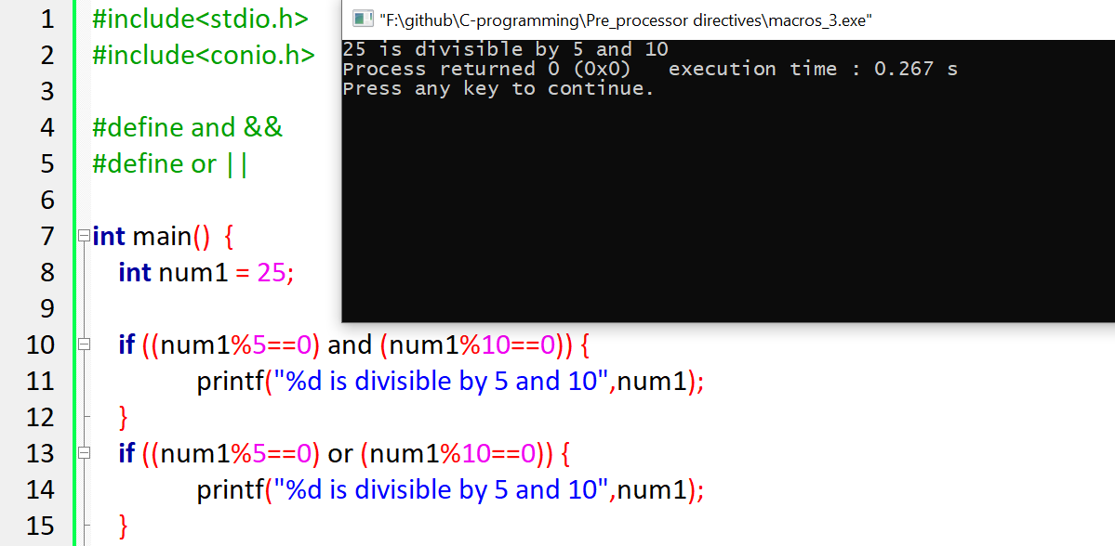

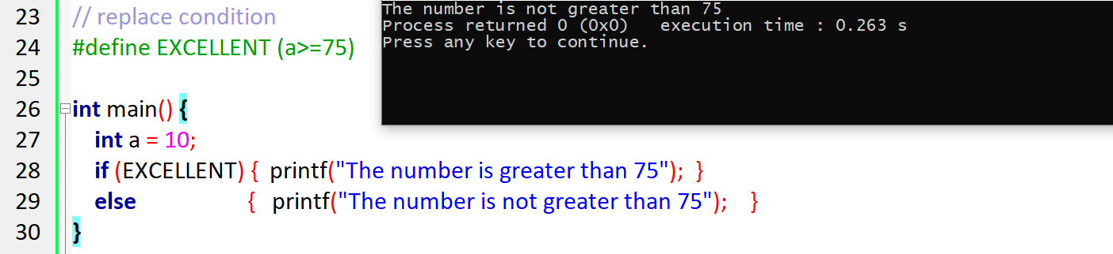

# Pre-defined MACROS

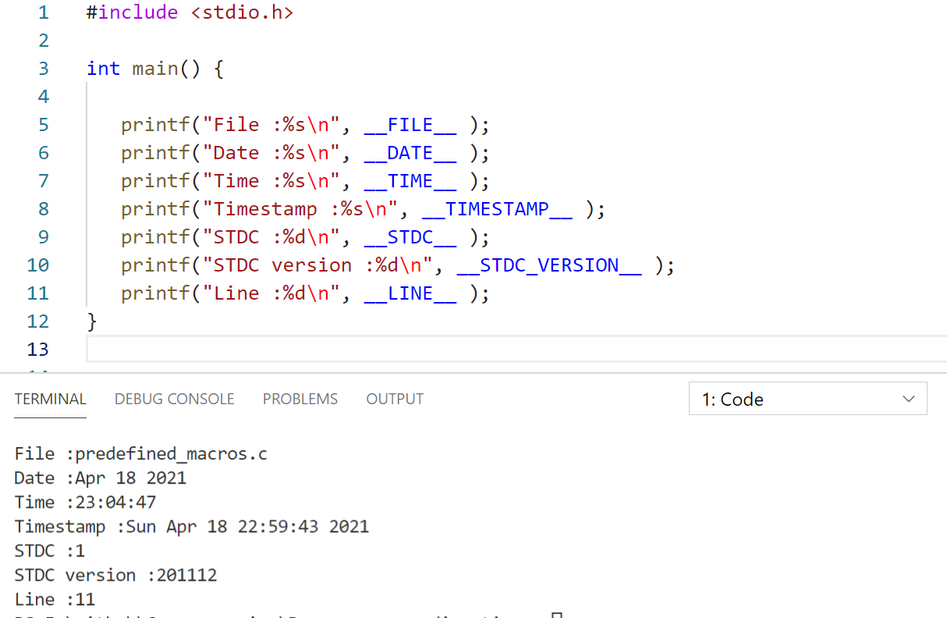

# **#operator**

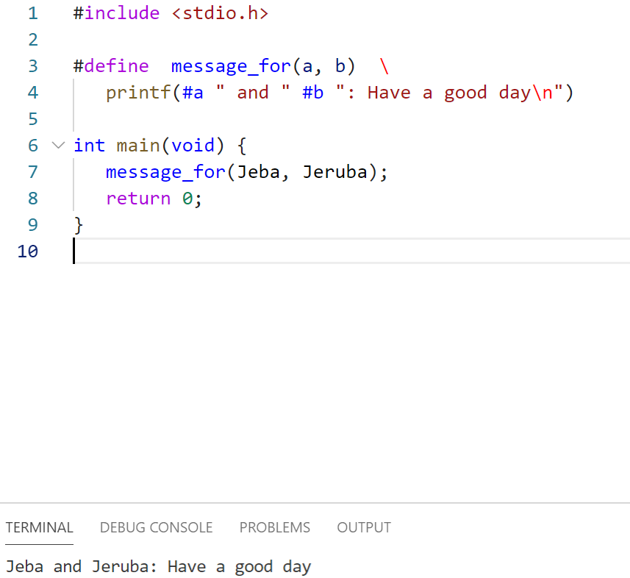

# **##operator**

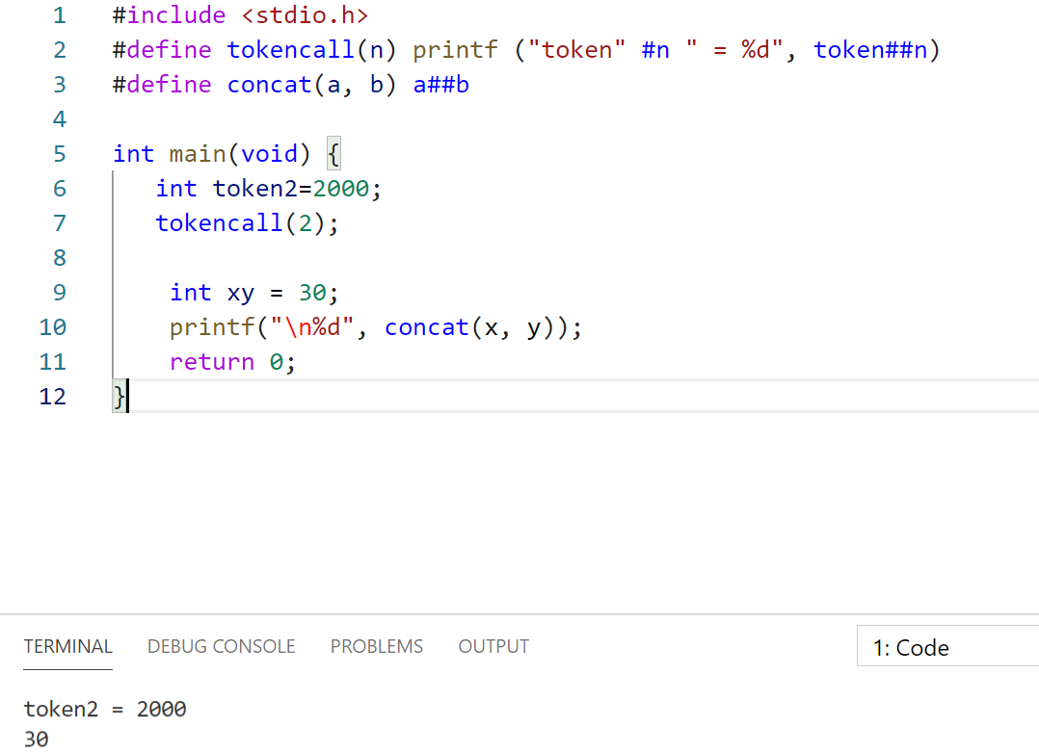

# **Conditional_compilation**

#ifdef()  
#ifndef()  
#else()  
#endif()

## **Refer conditional_compilation_1.c**

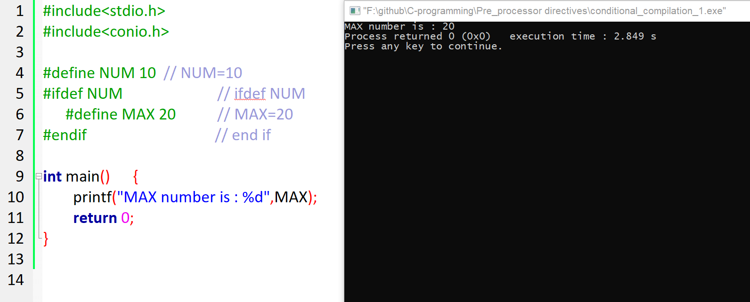

## **Refer conditional_compilation_1.c**

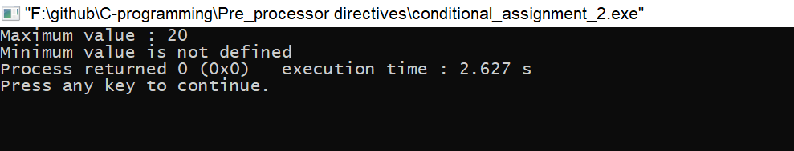

# **#Undef**

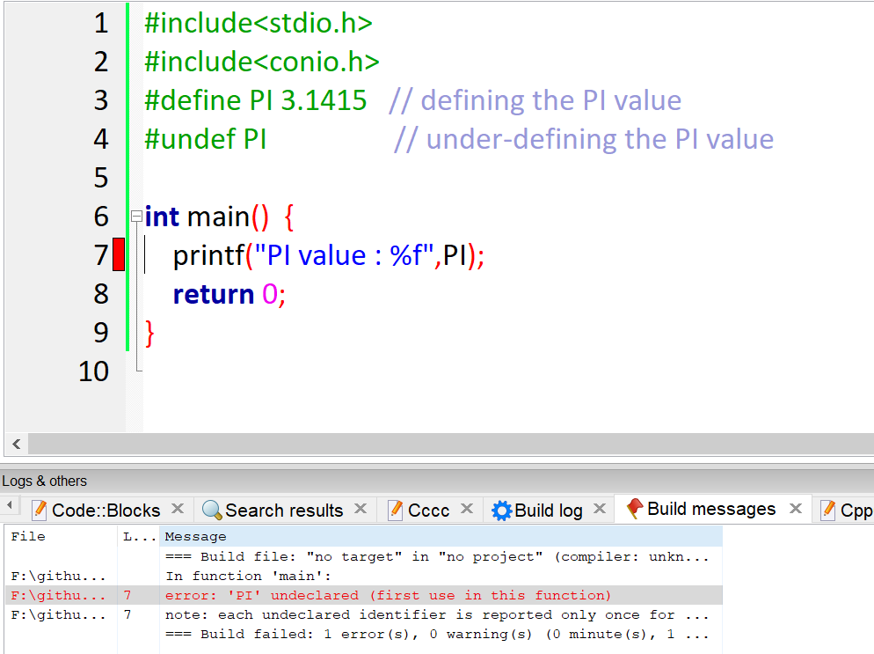

# **#error**

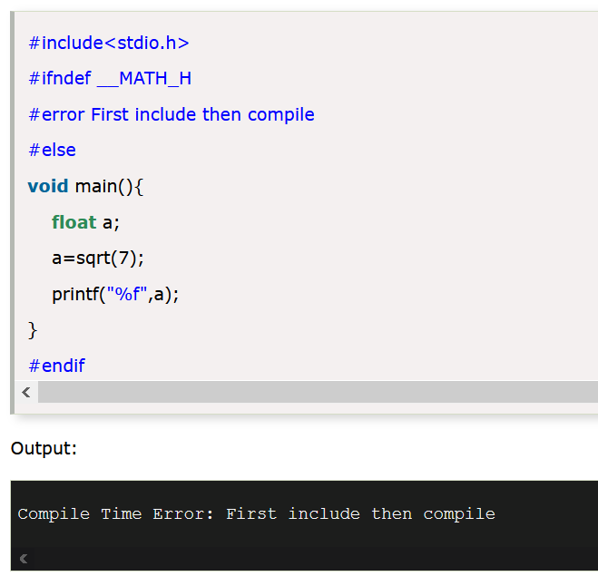

Here the main() will not at-all compiles so only they are hidden.

